**DDL (**data definition language **) Key Commands** are :

1. CREATE
2. ALTER
3. DROP
4. Creating a table

Command used : **CREATE**

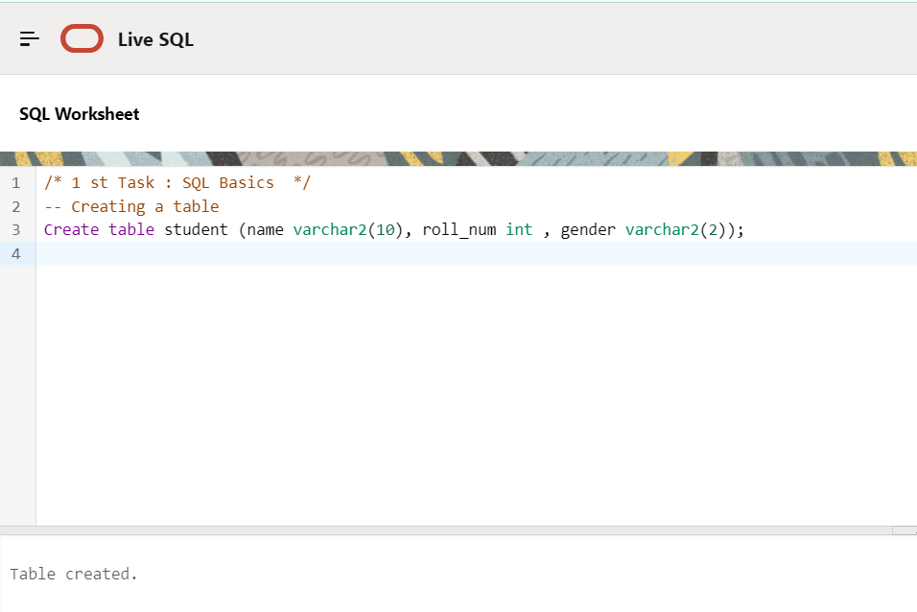

1. Inserting rows

Command used **: INSERT**

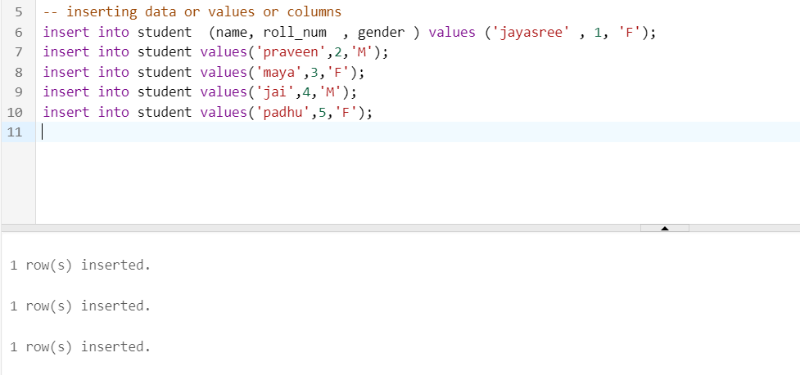

1. Retrieval of data

Command Used **: SELECT**

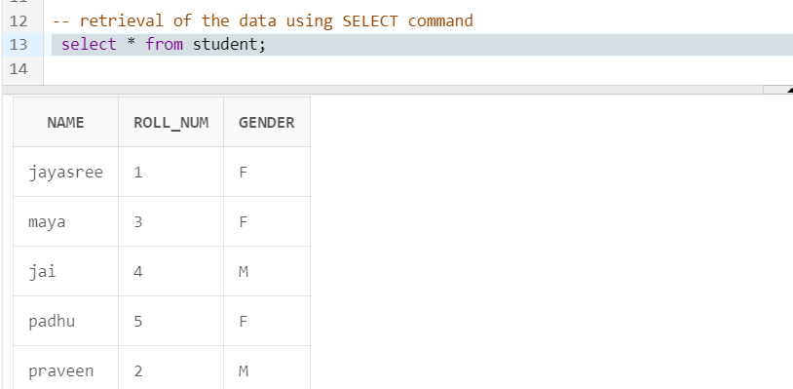

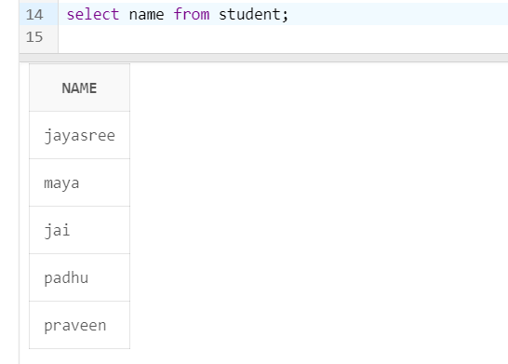

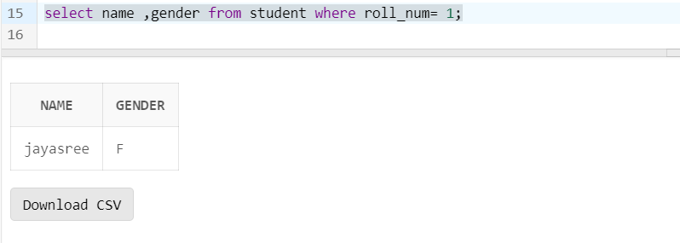

**Desc command :**  describes the data type of each column of a table.

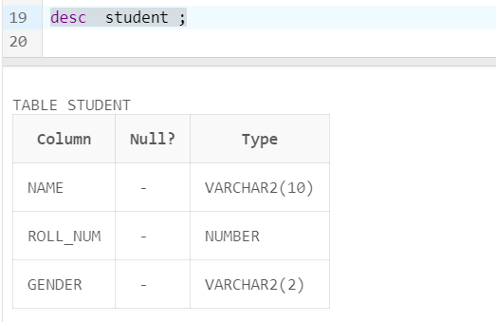

1. Modifying an existing table.

Command Used : **ALTER**

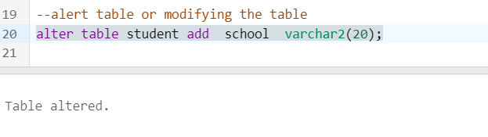

After modification

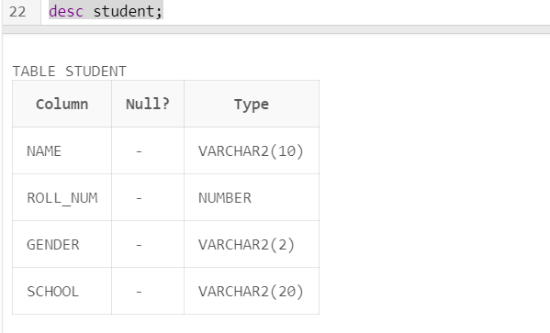

Deleting or Dropping a column

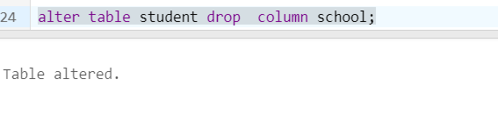

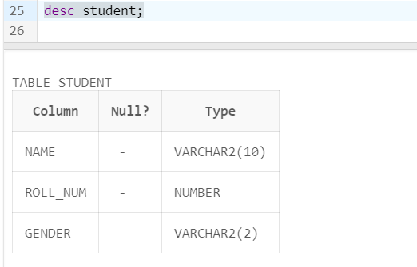

1. Deleting or Dropping the entire table

Command Used : **DROP**

